ELECTRONICS Task -4

NAME: - Aditya Mishra

DEPARTMENT: - Electronics and Communication

COLLEGE: - Manipal Institute of Technology, Manipal

CITY: - Udupi COUNTRY: - India

LEARNER MAIL: - [aditya34.mitmpl2024@learner.manipal.edu](mailto:aditya34.mitmpl2024@learner.manipal.edu)

**FIRST ORDER CIRCUITS**

A first-order circuit is an electrical circuit that has one energy storage element, either a capacitor or an inductor, and a resistor.A first-order circuit is characterized by a first-order differential equation that describes the relationship between the input and output signals.

The circuit's response to a change in voltage or current is exponential.

The two types of first-order circuits are the RC (resistor-capacitor) circuit and the RL (resistor-inductor) circuit.

**Resistor-Capacitor (RC) circuit**

A first-order resistor-capacitor (RC) circuit is an electrical circuit that contains one resistor and one capacitor and is the simplest type of RC circuit. RC circuits are fundamental to many electronic systems and are used in a variety of applications, including relaxation oscillators and filters.

In an RC circuit, the resistor limits the current, which causes the capacitor to charge and discharge at a specific rate. When voltage is applied to the circuit, the capacitor begins charging.

The time constant of the circuit, represented by the symbol τ, is the time it takes for the response to rise from zero to 63% of its final value, or to fall to 37% of its initial value. The time constant is calculated by the formula τ = R × C. The smaller the value of τ, the faster the circuit response.

RC circuits can be used to filter signals by blocking some frequencies while passing others. The two most common types of RC filters are high-pass and low-pass filters.

RC circuits are used in many electronic devices and systems, including relaxation oscillators, such as neon lamp oscillator circuits.

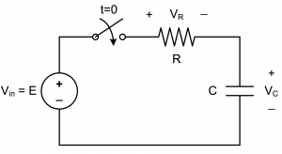

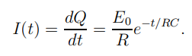

Above equation is the final result of the first order differential equation of the RC Circuit.

**Inductor-Capacitor (LC) circuit**

An LC circuit (also called a resonant or tank circuit) consists of an inductor (L) and a capacitor (C) connected. These components create an oscillatory system where energy is exchanged back and forth between the electric field of the capacitor and the magnetic field of the inductor.

These components are typically connected in either:

* **Series:** The inductor and capacitor are connected end-to-end, and the same current flows through both components.
* **Parallel:** The inductor and capacitor are connected across the same two points, and the voltage across both is the same.

The LC circuit is primarily known for its ability to oscillate at a natural resonant frequency, determined by the equation:

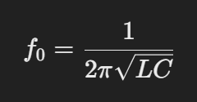

Where:

* f0​: Resonant frequency (Hz)
* L: Inductance (Henries, H)
* C: Capacitance (Farads, F)

At this frequency, energy oscillates between the inductor and capacitor, with minimal losses in an ideal circuit.

Applications:-

* **Oscillators:** Generating a stable frequency in radios, clocks, and communication systems.
* **Filters:** Select specific frequencies in radio receivers (band-pass or band-stop filters).
* **Tuning Circuits:** Matching circuits to desired signal frequencies (e.g., tuning radios).
* **Energy Storage and Transfer:** Found in wireless charging systems and resonant power converters.

Differential Equation for LC Circuits: -

The behaviour of an LC circuit can be described using Kirchhoff's laws:

1. **Series LC Circuit:**

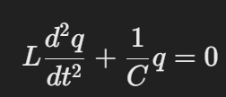

Here, *q* is the charge on the capacitor

1. **Parallel LC Circuit:**

Here, v is the voltage across the capacitor (or inductor).

Both equations show simple harmonic motion.

**SECOND ORDER CIRCUITS**

Second order circuits are electrical circuits characterized by having a second order differential equation governing their behaviour. These circuits typically contain two independent energy storage elements, such as:

1. Inductors (store energy in magnetic fields)
2. Capacitors (store energy in electric fields)

The interaction between these two storage elements gives rise to second-order dynamics. Second-order circuits are common in filters, oscillators, and systems involving transient and steady-state responses.

**Second Order RLC Circuit**

An **RLC circuit** is an electrical circuit consisting of three primary components:

1. **Resistor (R):** Dissipates energy as heat.
2. **Inductor (L):** Stores energy in its magnetic field.
3. **Capacitor (C):** Stores energy in its electric field.

These components can be arranged in **series** or **parallel**, and the behaviour of the circuit depends on their configuration and the applied voltage or current.

Types of RLC Circuits :-

1. **Series RLC Circuit:**
   * The resistor, inductor, and capacitor are connected in series.
   * The same current flows through all components.
   * Governing equation (for voltage across the circuit):
   * A black background with white text

     Description automatically generated
2. **Parallel RLC Circuit:**
   * The resistor, inductor, and capacitor are connected in parallel.
   * The voltage across each component is the same, but the currents through each component differ.
   * Governing equation (for current across the circuit):

**Key Parameters of RLC Circuits:**

1. **Natural Frequency (*ωn*​):**
   * The frequency at which the circuit would oscillate if there were no damping.
   * A black background with white text

     Description automatically generated
2. **Damping Factor (*ζ*):**
   * Determines the type of response (oscillatory or non-oscillatory).
   * A math equation with white letters

     Description automatically generated with medium confidence
3. **Resonant Frequency (*fr*​):**
   * The frequency at which the impedance is minimum in a series circuit, or the admittance is maximum in a parallel circuit.
   * A math equation with numbers and symbols

     Description automatically generated​

**RC Transient Analysis (LT Spice)**

Schematic for the above screenshot

It is the DC Analysis of a resistor circuit where the input voltage is 10V and the resistor is of 10 ohms the current and the current in the resistor is same as the current drawn from the source

It is the AC analysis of Passive Filter in which it is reducing the unwanted low frequencies signals

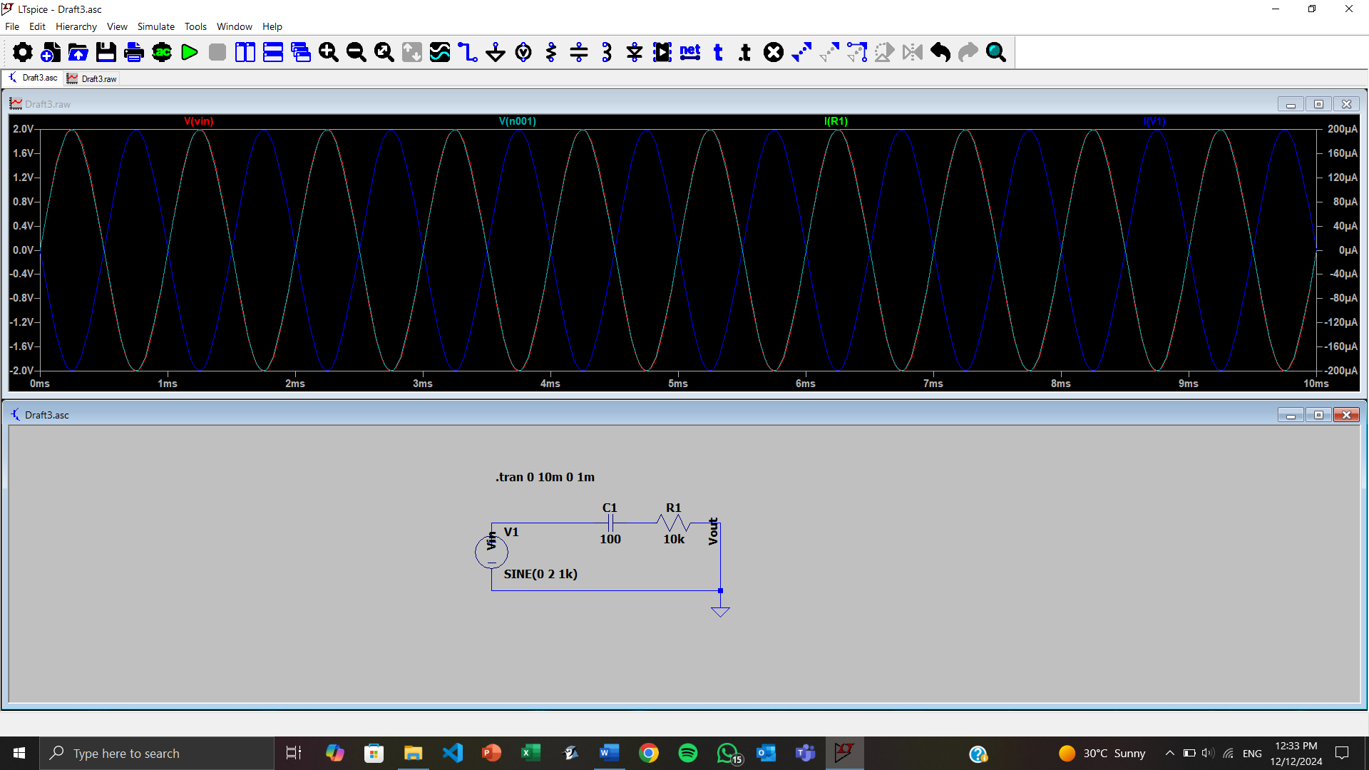

It is the Transient Analysis of an RC Charging Circuit where the waveform shows the charging and discharging of the capacitor

Inverting OPAmp it can be seen that the amplitude of the wave is amplified but the phase is changed by 180 degress

Non Inverting OPAmp in which the input signal is amplifies but remains in the same phase as input sinusoidal waveform.

Input waveform sinusoidal Full wave centre tap before rectification (Input Signal)

Output waveform sinusoidal after rectification Full wave centre tap after rectification (Output Waveform)

Green and red waveform is overlapping

Voltage Regulator caps the voltage to 5v only

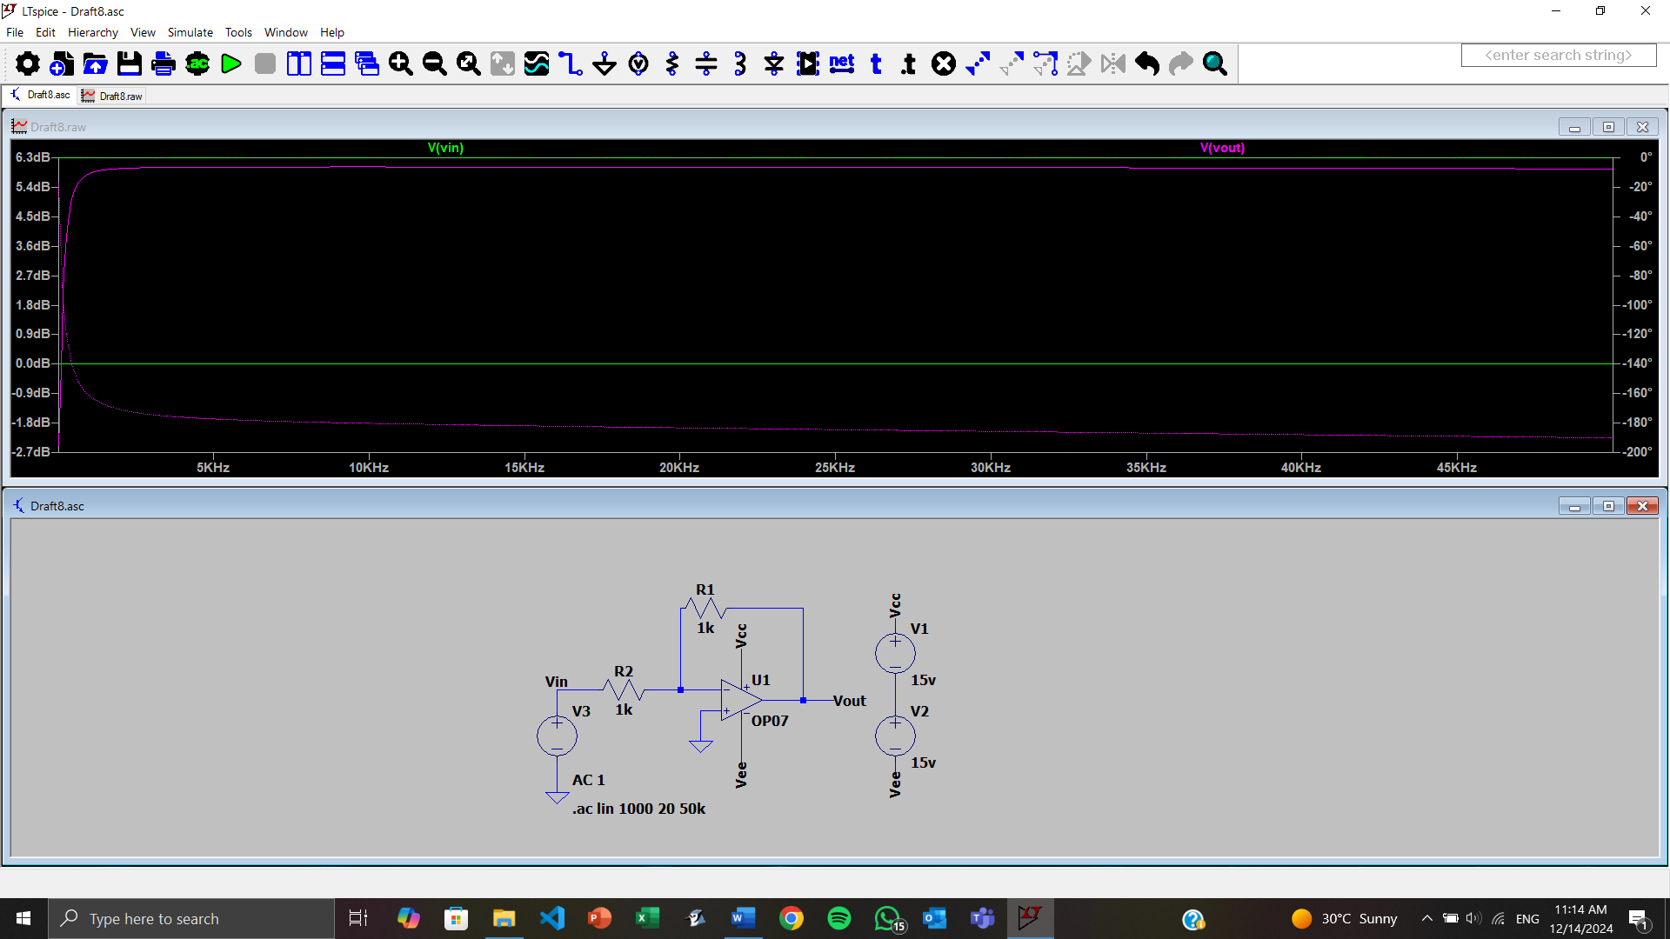Frequency Analysis of Amplifier

With increase in frequency the noise in the signal gradually reduces for half of the wave and vice versa for second half of the wave and the green line is the input signal without noise.

Simulation of Wein Bridge Oscillator:- Ratio of R2 to R1 should be slightly greater than 2 to form oscillations and and the red indicates the region where the ratio is one third of the initial ratio.

It is a Voltage Divider and the graph shows that the output voltage is reduced and is divided among resistor 1 and 2 by a ratio of R1 by R2 that is 0.5